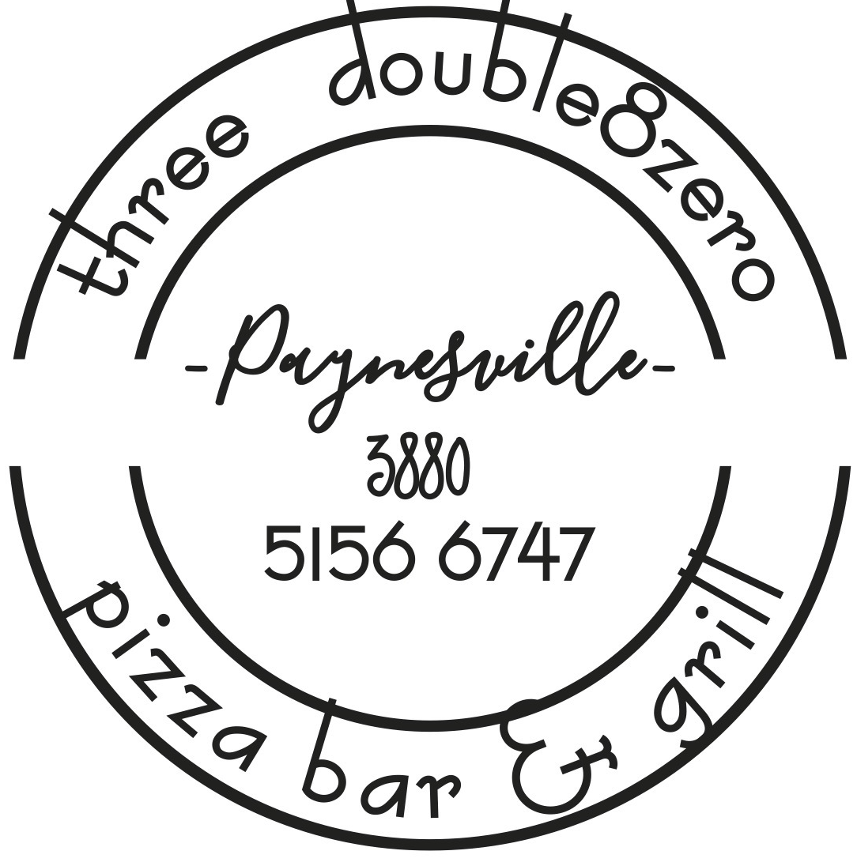

Lunch Menu served from 11.45am

Bruschetta $16
Turkish loaf oven baked with basil pesto, topped with cherry tomato, red onion, Bocconcini cheese & drizzled with Olive oil. (GFO/V/VG)

Crusty Cob Loaf $10
Oven baked cob with sides of garlic butter & tomato kasoundi relish (V/VG)

Crusty Cob Loaf with Cheese $12
Oven baked cob with sides of garlic butter & tomato kasoundi relish

Arancini balls $19
Roast Capsicum, mozzarella & parmesan flavoured arancini balls served with rich tomato passata & aioli (V)

Battered Fish Market Prices
Local sourced fresh fish, 3880 beer battered & served with chips, salad & tartare (GFO)

Thai Style Beef Salad $26
Pan fried Marinated Beef served with a pad Thai noodles greens crispy shallot, & Our famous in house Thai style dressing (GFO)

Southern Fried Chicken Burger $24
Southern Fried chicken tenders layered with Lettuce, cheese, Tomato & BBQ sauce and served with onion rings

The OMG Steak Sanga $26
Chargrilled striploin with bacon, egg, caramelised onion, lettuce, cheese, tomato relish on a Sourdough roll with fries

Salt and Pepper Squid $25.5
Lightly dusted squid fried served with Chips and Salad

Prawn Pasta $28
Pan fried prawns sauteed with garlic, chorizo, chilli & tomatoes served with pappardelle pasta and,Shaved parmesan

Pie $24.50
House made pie of the day served with chips, salad & relish

Please turn for more options
(GFO) gluten free (V) vegetarian (VG) Vegan

15% Surcharge applies on Public Holidays

Dukkha Crusted Salmon $31
Pan fried salmon fillet served with a warm dressed French lentil salad, crispy pancetta, greens & orange reduction

Red Wine Lamb Backstrap - $30 Served with Chat Potato and Vegetables
White Bean Chilli $26
Slow cooked white beans with spiced roasted sweet potato, capsicum, chilli & tomato served with fluffy coconut rice & guacamole (GF/VG/V)

Beef Brisket Ragu $28
served with pappardelle pasta & grand pandano Parmesan

Lentil Salad $26
Roasted Cauliflower, beetroot, Dutch carrot & pumpkin wedges served with grilled field mushrooms, dressed Fresh lentils, avocado smash & rocket (V/VG)

Three double8zero Charcuturie Board $27
Sliced cold meats, cheeses, local quince paste, local relish/pickles, antipasto mix & crispbread (GFO)

Club Sandwich. $24.50
Chicken, Swiss cheese, bacon, lettuce, tomato and kewpi mayo

Beef Brisket. $32
Beef Brisket with Smokey BBQ sauce served with Chat Potatoes and vegetables

Pan Fried Garlic Prawns $28
Served with fluffy coconut rice

Curry of the day $28
Served with rice

Soup of the Day $10
See specials board

Saint Louis Style BBQ Pork Ribs. $27
Served with Salad & Fries

Grilled Veggie Stack $23
Seasonal Vegetables served with a Balsamic dressing (V/VG)

(GFO) gluten free (V) vegetarian (VG) Vegan

15% Surcharge applies on Public Holidays

