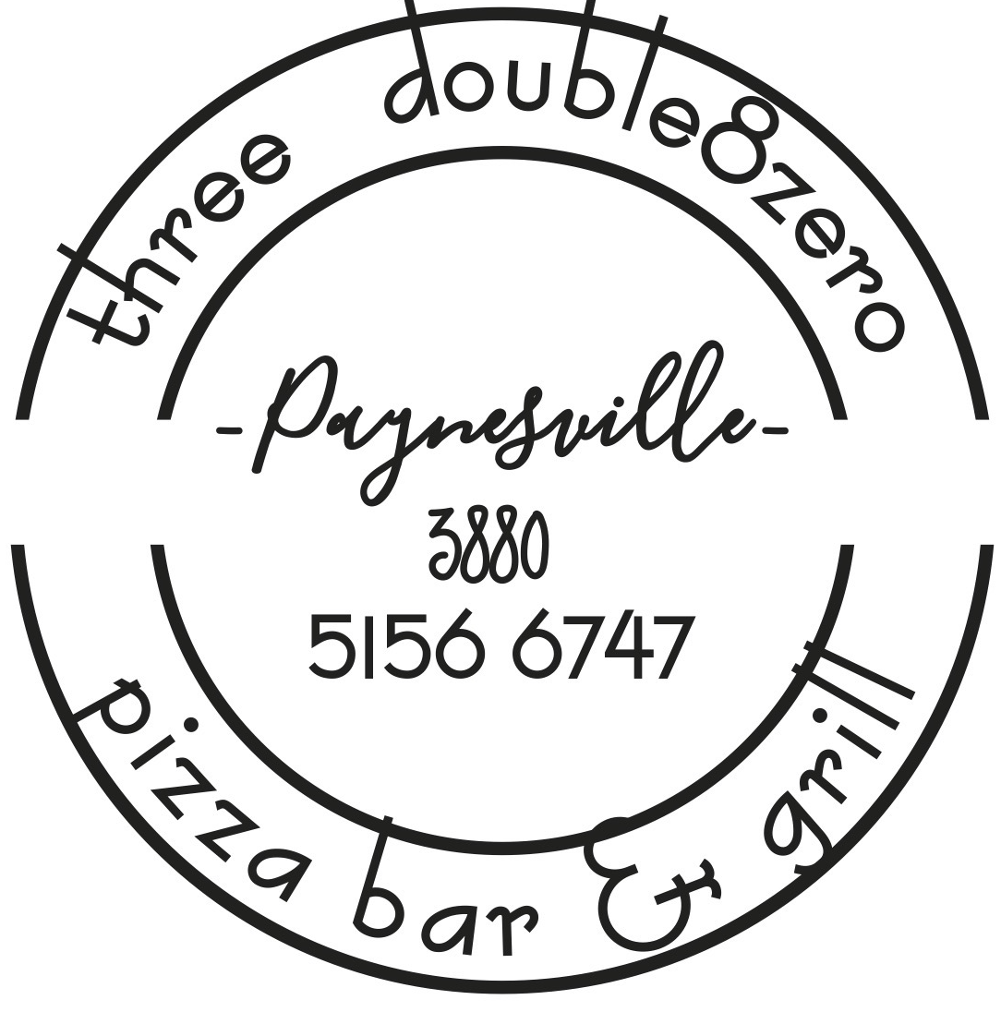

Lunch Menu served from 12.00pm. Please note our kitchen will be closed between 11.30am – 12pm

Bruschetta $16
Turkish loaf oven baked with basil pesto, topped with cherry tomato, red onion, Fetta & Pomegranate drizzle. (GFO/V)

Crusty Cob Loaf $10 add cheese $12 (V)
Oven baked cob with sides of garlic butter & tomato kasoundi relish

Battered Fish Market Prices (GFO)
Local sourced fresh fish, 3880 beer battered & served with chips, salad & tartare

Southern Fried Chicken Burger $24
Southern Fried chicken tenders layered with Lettuce, cheese, Tomato & BBQ sauce and served with onion rings

The OMG Steak Sanga $26
Chargrilled striploin with bacon, egg, caramelised onion, lettuce, cheese, tomato relish on a Turkish roll with Chips

The 3880 Beef Burger $25.50
Beef Pattie, egg, onion, bacon, tomato, cheese and lettuce served with chips

Salt and Pepper Squid $26
Lightly dusted squid fried served with Chips and Salad & Aioli

Garlic Prawn Pasta $28
Pan fried prawns sauteed with garlic & onion, served with pappardelle pasta and Shaved parmesan

Chilli Prawn Pasta $28
Pan fried prawns sauteed with chorizo, chilli & onion with pappardelle pasta and Shaved parmesan

Chicken Parma $25
Served with chips and salad

Soup of the Day $14.50
See specials board

Chickpea & Lentil Burger $25.50 (V)
Served with Garden Salad, tomato, Swiss cheese & Tomato relish

Caesar Salad $18
Cos lettuce, bacon, croutons, avocado, poached egg with house made dressing and shaved parmesan cheese to finish
Add Moroccan Chicken $23
15% Surcharge applies on Public Holidays

