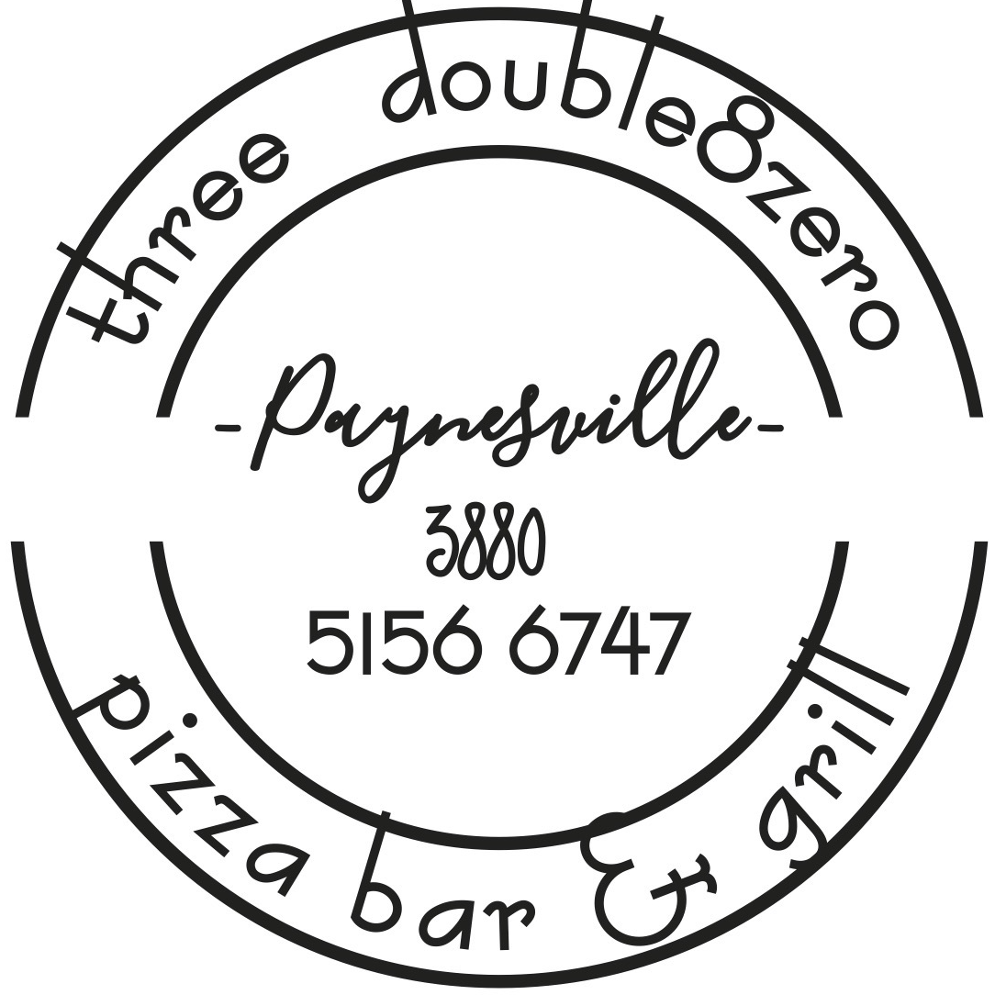

3880 Breakfast Menu - Breakfast served 7.30am until 11.30am

Fluffy Ricotta & Vanilla Hotcakes $17.5
Served with Seasonal Berries & lightly whipped Vanilla Yoghurt(V)

Eggs Your way (local Free-range supplier) $13.50
Fried, poached or scrambled with toasted sourdough (V/GFO)

The OG Brekkie $27.50
Eggs your way, bacon, mushrooms, grilled tomato, potato rosti, chipolata, spinach, house made beans & toasted sourdough (GFO)

Corn & Zucchini Fritters $23
Served with poached eggs, avocado, halloumi cheese & tomato kasundi relish(V)

3880 Bene $19.50
Triple smoked ham, poached eggs, crispy buttery croissant, avocado smash & hollandaise sauce (GFO)

3880 Bene Florentine $19.50
Poached eggs, crispy buttery croissant and spinach (GFO)

3880 Bene Atlantic $24
Salmon, poached eggs, crispy buttery croissant, avocado smash & hollandaise sauce (GFO)

Chilli Scrambled $20
Scrambled eggs with Chorizo, chilli and onion

House made Beans with baked eggs $20
Served Spanish chorizo, fresh herbs, feta & toasted sourdough (GFO)

The Loaded Smash $23
Sourdough slices with avocado smash, tomato, onion & Olive Oil, Poached eggs & dukkha seasoning

The Best ever Bacon and Egg roll $12.50
2 fried eggs, grilled bacon, cheese, tomato relish on a seeded charcoal brioche roll

French Sticks $16.50
Croissant Served with maple syrup, whipped vanilla yoghurt and berry compote crumble

Crunchy maple infused Granola $15
Served with whipped vanilla yoghurt & seasonal berries (V)
Toasted Sandwich on Sourdough
with cheese $8.00
with Ham & Cheese $9.00
with Ham, cheese & tomato $10.50
Toast $6.50
Served with butter & condiment (Vegemite, honey, strawberry jam, peanut butter
Croissant with butter & condiment $6.50
Thick cut Fruit loaf with butter $6.50
Banana bread with Whipped Vanilla yoghurt $11.50
Sides $4.50
Bacon, potato rosti, house made beans, mushrooms, tomato, avocado, toast, hollandaise, chipolata
15% Surcharge applies on Public Holidays

