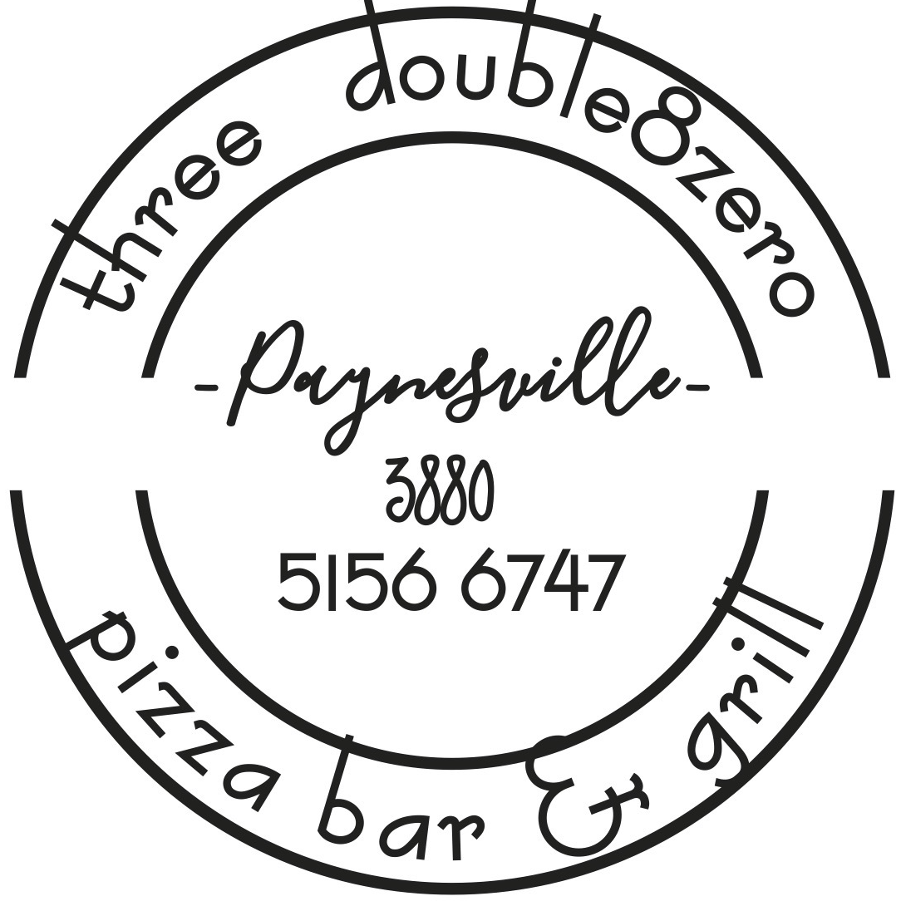

Breakfast Menu – Available ALL Day. Please note our kitchen will be closed between 11.30am – 12pm

Eggs Your way (local Free-range supplier) $13.50
Fried, poached or scrambled with toasted sourdough (V/GFO)

The OG Brekkie $27.50
Eggs your way, bacon, mushrooms, grilled tomato, hash brown, chipolata, spinach & toasted sourdough (GFO)

3880 Bene $19.50
Triple smoked ham, poached eggs, crispy buttery croissant, avocado smash & hollandaise sauce (GFO)

Brekky Roll $13.50
2 fried eggs, grilled bacon, cheese, tomato relish on a Milk Bun

Crunchy maple infused Granola $15
Served with vanilla yoghurt & seasonal berries (V)

Chilli Scrambled $20
Scrambled eggs with Chorizo, chilli and onion

The Loaded Smash $23
Sourdough slices with avocado smash, tomato, onion & Olive Oil, Poached eggs & dukkha seasoning

Maple Bacon Pancakes $20
2 House made Pancakes served with Maple Bacon and a choice of Ice Cream or Yoghurt & Berries

French Toast “Pain Perdu” $18
Served with Yoghurt, Berries and Maple syrup

Vegetarian Frittata $18
Infused with locally sourced vegetables & served with a Garden Salad & Tomato Relish

Toasted Sandwich on Sourdough
with cheese $8.00
with Ham & Cheese $9.00
with Ham, cheese & tomato $10.50

Toast $6.50
Served with butter & condiment (Vegemite, honey, strawberry jam, peanut butter, Nutella
Croissant with butter & condiment $6.50
Thick cut Fruit loaf with butter $6.50
Banana bread with Whipped Vanilla yoghurt or butter $11.50
Sides $4.50
Bacon, mushrooms, tomato, avocado, toast,
hollandaise, chipolata, hashbrown
15% Surcharge applies on Public Holidays

